JNTUA College of Engineering (Autonomous) Ananthapuramu-515002 (A.P) INDIA
TEQIP-III Sponsored One-Week FDP on “Leadership Skills”, a twinning program conducted by the Department of Humanities from 19-08-2019 to 24-08-2019 at JNTUACEA
REPORT
The Department of Humanities and Social Sciences, JNTUA College of Engineering, Ananthapuramu, in collaboration with University College of Engineering & Technology, Bikaner Technical University, Bikaner, Rajasthan organized a One-Week Faculty Development Programme on “Leadership Skills” from 19-08-2019 to 24-08-2019 on the JNTUACEA college premises. The FDP aimed to upgrade teaching, training, communication and leadership skills in the faculty. This program enabled the participants to develop an appreciation for the changing roles and responsibilities of the teachers and to prepare for the same.. About 150 participants from different parts of the country had participated in this program.
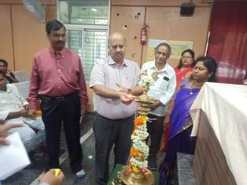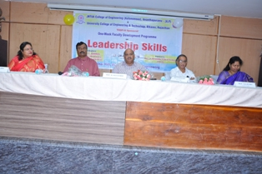
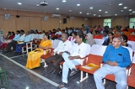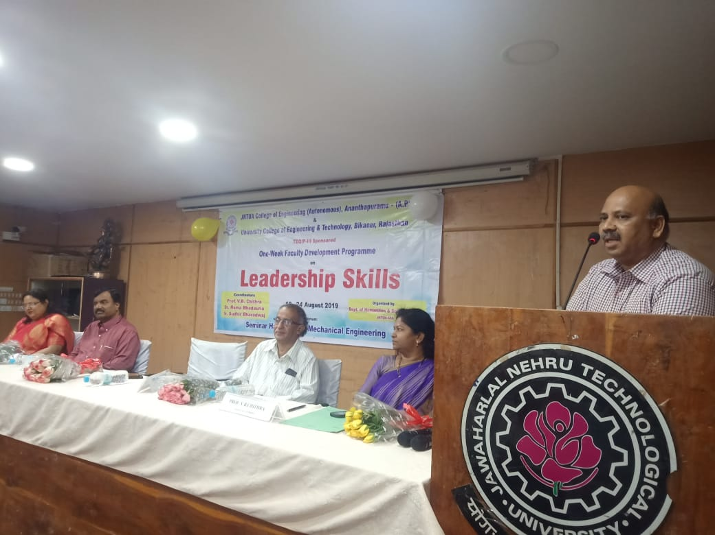
The program started with the registration at 8:30am on 19th September followed by the inaugural function. Prof.M.Vijay Kumar, Registrar of JNT University, Anantapur and Prof.D.S.Kesava Rao, Professor of English. NIT Warangal, Prof. K. Govinda Rajulu, the Principal of JNTUACEA and the coordinators from JNTUACEA & UCE&T, Bikaner lighted the lamp marking the inauguration of One-Week FDP.

Prof. K. Govinda Rajulu, Principal of the college had presided over the function. The Coordinator of the program, Dr. V. B. Chithra welcomed the guests and participants. She has detailed about the courses offered by the department of Humanities. Further, she has highlighted the objectives of the FDP with an emphasis on reinforcing the communication skills for teachers for effective instructional delivery system. Dr.Ruma Bhadauria, the Coordinator from UCE&T, Bikaner had elaborated on the importance of leadership skills for the academicialns.
In his address, Prof. K. Govindarajulu emphasized the significance of the FDP and importance of leadership skills for the professionals.

The chief guest, Prof. M. Vijay Kumar in his inaugural speech stated the responsibilities of a teacher as leader and advised them to update their leadership skills.
Key Note Address was presented by the Resource Person Prof. D.S.Kesavaa Rao Garu, Department English, NIT Warangal. In his speech he briefly introduced the proposed topics/themes to be discussed in the Program.

Directors Prof. K.B.Chandra Sekhar, Prof. B.Eswar Reddy. Prof..G.Prasanthi, Prof.C.Shobha Bindhu, and Prof.V.Sankar, Prof.Vaishali, Prof. P.Sujatha, Prof.R.Padma Suvarna, Prof. S.Vasundra Prof.R.Bhuvana Vijaya, Dr.B.Chandra Mohan Reddy, Dr.T.Narayana Reddy, Prof.E.Aruna Kanthi, Prof.R.Bhavani, Dr..S.Sharada, and other faculty members of the department graced the inaugural function.

The first two sessions were handled by Prof. D.S. Kesava Rao. In his lecture, Prof.Kesava Rao
delivered a thought-provoking lecture on “Academic Leadership” covering the essential skills like Strategic Thinking, Planning and Delivery, People Management, Change Management, and Communication that a leader should possess.
Eminent teachers from reputed universities like IIT Tirupati, NIT Warangal, Central Universities, State Universities and Special trainers from Master Training Academy, Bangalore and Soft Skills Trainer served as resource persons for the One-week programe. Prof. M. L. Sai Kumar, Prof. S. V. Pulla Reddy, Prof. P. Lokananda Reddy, Prof. Ch.Rama Prasada Rao, Prof. Vamshikrishna Reddy, Prof. Vaneet Kashyap, Mr.V.V.Rama Krishna Sasti, Dr. B. Susheela, Dr. Ruma Bhadauria, Dr. Sudhir Bhardwaj etc were resourceful in providing the inputs for the thrust areas like, Academic Leadership, Team Building, Leadership and Human Rights, Role of Academic Leadership in Higher Education, Integrating Positivity and Values, Ethics in Educational Leadership, Emotional Intelligence, The Role of Effective Communication in Leadership and Team Management, Barriers to Effective Communication, Organizational Behavior on Building High Performance Teams, Spiritual Intelligence, Stress Management, The What, Why, and How of Leadership Development, Managing Conflicts, Leadership Styles, Qualities of a leader.

The One-Week programme came to an end on 24-08-2019 with valedictory function preceded by feedback of the participants. They expressed their immense pleasure in conducting a program like this which genuinely reinforced their leadership skills.
The Vice-Chancellor of the University, Prof. S. Srinivas Kumar served as the Chief Guest and reinstated the importance of the program and congratulated the organizing team for making the programme a grand success.

Principal Prof. K.Govinda Rajulu congratulated the coordinators. Vice Principal Prof. M.L.S. Deva Kumar and the Convenor of the Program Dr.V.B.Chithra expressed their gratitude towards everyone for making the program a grand success. Prof. K. Govinda Rajulu, Principal of JNTUACE, Anantapur distributed the participation certificates to the delegates and finally the program was ended with the national anthem.
